4

**e-Project**

**Report**

**Supervisor :** Vo Duc Thien

**Curriculum:** ACCP i7.1

**Semester:** 2 – DISM.

**Batch Code:** 1007E

**Team Leader:** Le Ngoc Thanh

**Members :** Tran Le Quoc Hung

Quach Vinh Quang

Tran Cam Thanh



This is to certify that

**Mr. Le Ngoc Thanh**

has successfully designed and

developed

**Leave Management System**

Submitted by:

**Le Ngoc Thanh**

Date of Issue: 15/03/2012

Authorized Signature: \_\_\_\_\_\_\_\_\_\_\_



This is to certify that

**Mr. Tran Le Quoc Hung**

has successfully designed and

developed

**Leave Management System**

Submitted by:

**Tran Le Quoc Hung**

Date of Issue: 15/03/2012

Authorized Signature: \_\_\_\_\_\_\_\_\_\_\_



This is to certify that

**Mr. Quach Vinh Quang**

has successfully designed and

developed

**Leave Management System**

Submitted by:

**Quach Vinh Quang**

Date of Issue: 15/03/2012

Authorized Signature: \_\_\_\_\_\_\_\_\_\_\_



This is to certify that

**Mr. Tran Cam Thanh**

has successfully designed and

developed

**Leave Management System**

Submitted by:

**Tran Cam Thanh**

Date of Issue: 15/03/2012

Authorized Signature: \_\_\_\_\_\_\_\_\_\_\_

**1. Problem Statement**

Our client is a manufacturer of the telecom products, like mobiles, landlines, wireless phones, etc . with different features like speaker phone, in - built phone book, call tracking system, SMS facility, voice recording features, answering m/c facility, etc .. Several telecom companies like BSNL, etc . Actually the clients of this manufacturer used to visit or ask for the sales person to visit their premises in order to select the type of the product, and place a request for some quantity of the products as per their requirement. Also they receive the order from some customers who want to have a parallel connection for their existing telecom connection with some features like speaker phone, answering m/c incorporated, etc.... Also due to the increase in the vendors of various telecom providers, the increase in demand for the telecom product manufacturers is increased.

Due to some arrears in the delivery of the product, or due to some failures

Table of Contents

**1. Problem Statement………………………………………………….7**

**2. Use-Case Diagram ………………………………………………….8**

**3. Use-Case Specification …………………………………………….10**

**4. Flow Chart………………………………………………………….21**

**5. Database Design……………………………………………………37**

**6. Site Map…………………………………………………………….42**

**7.Interface System…………………………………………………….43**

**8. Task Sheet…………………………………………………………..55**

**9. Installation Guide…………………………………………………..56**

**10. User Guide………………………………...……………………….72**

**1. Problem Statement**

Every Organization has many managers, who are responsible for all the activities in the organization. These managers manage different aspects of the organizational management issues, such as manufacturing, production, Marketing, etc; one such essential management issue is **“Industraial Manpower Resource Organiser” (IMPRO).**

As years progressed, the approach of the management changed towards the human capital. Now Hierarchical Organization is part of every organization, and has its own identity and importance. In this scenario, the bigger organizations need to put lot of effort in the management of human Resources, as they are underlying capital asset to the organization. In doing so, along with times, the Organization Information changed from its basic operations to more strategic approach.

Some of the features are.

* Finding ground level employee performance by the topmast manager.
* Maintenance of profile details of the employees, and retrievals as and when required.
* Overall & detailed view of the organization hierarchy, which is very much essential in making effective decisions.
* Judging the potentiality of the employees.
* Maintenance of the data when the organization has many branches spread over wide geographical area.
* Accessing one branch information from another branch.
* Future planning issues based on the current HR information.
* Employees success planning.
* Vacancy situations and their priority /effect on the organizations performance.
* Employee motivational & conflict resolving issues.

As the whole project is based on the logical perspective of an ideal organization’s Human Capital Management structure, the physical implementation has no fixed rules, thus implementing the concept little difficult.

**2. Use-Case Diagram**



Picture 1 – Actor Admin.



Picture 2 – Actor HR Managerment.



Picture 3 – Actor Departments Manager.



Picture 4 – Actor Employee.

**3. Use-Case Specification**

**3.1 List of Actors**

|  |  |  |
| --- | --- | --- |
| **No.** | **Actor** | Comment |
| **1** | **Admin** | *Manage all* |
| **2** | **HR Managerment** | *Manage Employee , Search Department,Search Vacancy, Process Vacancy, Rotate Employee* |
| **3** | **Departments** | *Manage Vacancy , Section and Search Employee* |
| **4** | **Employee** | *Search and Update information, Search Employee* |

**3.2 List of Use-Case**

|  |  |  |
| --- | --- | --- |
| **No.** | **Use-Case** | **Comment** |
| **1** | **Login** | *Users logged into the system* |
| **2** | **Logout** | *Users exit the system* |
| **3** | **Search Account** | *Delete an account in account list* |
| **4** | **Add Section** | *Add a section in section list* |
| **5** | **Update Section** | *Update details of section* |
| **6** | **Delete Section** | *Delete a Section in Section list* |
| **7** | **Search Section** | *Find section based on section’s name* |
| **8** | **Add Employee** | *Add an employee in employee list* |
| **9** | **Update Employee** | *Update details of employee* |
| **10** | **Delete Employee** | *Delete an employee in employee list* |
| **11** | **Search Employee** | *Find employee based on employee’s name or full name* |
| **12** | **Add layer** | *Add a layer in layer list* |
| **13** | **Update Layer** | *Update detail of layer* |
| **14** | **Delete Layer** | *Delete a layer in layer list* |
| **15** | **Search Layer** | *Find layer based on layer’s id* |
| **16** | **Add Departments** | *Add an department in department list* |
| **17** | **Update Departments** | *Update detail of department* |
| **18** | **Delete Departments** | *Delete a department in department list* |
| **19** | **Search Department** | *Find department based on department’s name* |
| **20** | **Rotate Employee** | *Rotate employee between departments* |
| **21** | **Process Vacancy** | *Add employee in departments* |
| **22** | **Add Vacancy** | *Add a vacancy in vacancy list* |
| **23** | **Update Vacancy** | *Update detail of vacancy* |
| **24** | **Delete Vacancy** | *Delete a vacancy in vacancy list* |
| **25** | **Search Vacancy** | *Find vacancy based on vacancy’s number* |
| **26** | **View Information Employee** | *Details information of employee* |
| **27** | **Update Information Employee** | *Update information of employee* |

**3.3 Description**

**3.3.1 Login**

|  |  |
| --- | --- |
| **Use Case** | **Login** |
| Summary : | *Function “Login” allows user login to system with corresponding powers* |
| Major Events: | *Step 1 : When user start application “Form Login” will be displayed*  *Step 2 : User enter their username and password*  *Step 3 : Press button “Login” program will check username and password in database.*  *Step 4 : If exist program will display a confirmation message “Login Successful”*  *Else program will display a confirmation message “Login Failed”*  *Step 5 : User press button “Exit” to exit this form* |
| Other Events: |  |

**3.3.2 Logout**

|  |  |
| --- | --- |
| **Use Case** | **Logout** |
| Summary : | *Function “Logout” help user logout the program* |
| Major Event : | *Step 1 : When user want to signout click "Logout" on the program interface*  *Step 2 : Program will display a confirmation message “Do you want to sign out?”*  *Step 3 : If click “Yes” user will exit program and disconnect with database*  *If click “No” user will turn back application interface* |
| Other Events : |  |

**3.3.3 Search Account**

|  |  |
| --- | --- |
| **Use Case** | **Search Account** |
| Summary : | *Find account in account list* |
| Major Events : | *Step 1 : Click on tab “Search Account”*  *Step 2 : Enter name of account*  *Step 3 : Program will check this information in database*  *Step 4 : If exist program will display this account*  *Else Program will display a confirmation message “No account in account list”.* |

**3.3.4 Add Section**

|  |  |
| --- | --- |
| **Use Case** | **Add Section** |
| Summary : | *Function “Add Section” help user add a section to section list* |
| Major Events : | *Step 1 : Click on tab “Manage Section”*  *Step 2 : Press button “Add Section”*  *Step 3 : “Form Add Section” will be displayed. User enter information of section and press button “Add”*  *Step 4 :Program will display a confirmation message “Do you want to add section?”*  *Step 5 : If click “OK” section will be added into database and displayed in section list*  *If click “No” section won’t be added* |
| Other Events : |  |

**3.3.5 Update Section**

|  |  |
| --- | --- |
| **Use Case** | **Update Section** |
| Summary : | *Function “Update Section” help user update information of section* |
| Major Events : | *Step 1 : Click on tab “Manage Section”*  *Step 2 : Select a section wants to update then click button “Update Section”*  *Step 3 : “Form Update Section” will be displayed on screen , user edits information of section and then press button “Update”*  *Step 4 : Program will display a confirmation message “Do you want to update this section?”*  *If click “OK” section will be updated into database and displayed in section list*  *If click “No” section won’t be updated* |
| Other Events : |  |

**3.3.6 Delete Section**

|  |  |
| --- | --- |
| **Use Case** | **Delete Section** |
| Summary : | *Function “ Delete Section” help user delete a section from section list* |
| Major Events : | *Step 1: In tab “Manage Section” user can view section list*  *Step 2 :User can choose a section wants to delete and press button “Delete”*  *Step 3 :Program will display a confirmation message “Do you want to delete this section?”*  *Step 4 : If click “Yes” section will be deleted into database and don’t display in section list*  *If click “ No” Undelete section* |
| Other Events : |  |

**3.3.7 Search Section**

|  |  |
| --- | --- |
| **Use Case** | **Search Section** |
| Summary : | *Find section in section list* |
| Major Events : | *Step 1 : Click on tab “Manage Section”*  *Step 2 : Enter name of section*  *Step 3 : Program will check this information in database*  *Step 4 : If exist program will display this section*  *Else Program will display a confirmation message “No section in section list”.* |
| Other Events : |  |

**3.3.8 Add Employee**

|  |  |
| --- | --- |
| **Use Case** | **Add Employee** |
| Summary : | *Function “Add Employee” help user add an employee to employee list* |
| Major Events : | *Step 1 : Click on tab “Manage Employee”*  *Step 2 : Press button “Add Employee”*  *Step 3 : “Form Add Employee” will be displayed. User enter information of employee and press button “Add”*  *Step 4 :Program will display a confirmation message “Do you want to add employee?”*  *Step 5 : If click “OK”emlpoyee will be added into database and displayed in employee list*  *If click “No” employee won’t be added* |
| Other Events : |  |

**3.3.9 Update Employee**

|  |  |
| --- | --- |
| **Use Case** | **Update Employee** |
| Summary : | *Function “Update Employee” help user update information of employee* |
| Major Events : | *Step 1 : Click on tab “Manage Employee”*  *Step 2 : Select an employee wants to update then click button “Update Employee”*  *Step 3 : “Form Update Employee” will be displayed on screen , user edits information of employee and then press button “Update”*  *Step 4 : Program will display a confirmation message “Do you want to update this employee?”*  *If click “OK” employee will be updated into database and displayed in employee list*  *If click “No” employee won’t be updated* |
| Other Events : |  |

**3.3.10 Delete Employee**

|  |  |
| --- | --- |
| **Use Case** | **Delete Employee** |
| Summary : | *Function “ Delete Employee” help user delete an employee from employee list* |
| Major Events : | *Step 1: In tab “Manage Employee” user can view employee list*  *Step 2 :User can chose an employee wants to delete and press button “Delete”*  *Step 3 :Program will display a confirmation message “Do you want to delete this employee?”*  *Step 4 : If click “Yes” employee will be deleted into database and don’t display in employee list*  *If click “ No” Undelete employee* |
| Other Events : |  |

**3.3.11 Search Employee**

|  |  |
| --- | --- |
| **Use Case** | **Search Employee** |
| Summary : | *Find employee in employee list* |
| Major Events : | *Step 1 : Click on tab “Manage Employee”*  *Step 2 : Enter name of employee*  *Step 3 : Program will check this information in database*  *Step 4 : If exist program will display this employee*  *Else Program will display a confirmation message “No employee in employee list”.* |
| Other Events : |  |

**3.3.12 Add Layer**

|  |  |
| --- | --- |
| **Use Case** | **Add Layer** |
| Summary : | *Function “Add Layer” help user add a layer to layer list* |
| Major Events : | *Step 1 : Click on tab “Manage Layer”*  *Step 2 : Press button “Add Layer”*  *Step 3 : “Form Add Layer” will be displayed. User enter information of layer and press button “Add”*  *Step 4 :Program will display a confirmation message “Do you want to add layer?”*  *Step 5 : If click “OK” layer will be added into database and displayed in layer list*  *If click “No” layer won’t be added* |
| Other Events : |  |

**3.3.13 Update Layer**

|  |  |
| --- | --- |
| **Use Case** | **Update Layer** |
| Summary : | *Function “Update Layer” help user update information of layer* |
| Major Events : | *Step 1 : Click on tab “Manage Layer”*  *Step 2 : Select a layer wants to update then click button “Update Layer”*  *Step 3 : “Form Update layer” will be displayed on screen , user edits information of layer and then press button “Update”*  *Step 4 : : Program will display a confirmation message “Do you want to update this layer?”*  *If click “OK” layer will be updated into database and displayed in layer list*  *If click “No” layer won’t be updated* |
| Other Events : |  |

**3.3.14 Delete Layer**

|  |  |
| --- | --- |
| **Use Case** | **Delete Layer** |
| Summary : | *Function “ Delete Layer” help user delete a layer from layer list* |
| Major Events : | *Step 1: In tab “Manage Layer” user can view a layer list*  *Step 2 :User can choose a layer wants to delete and press button “Delete”*  *Step 3 :Program will display a confirmation message “Do you want to delete this layer?”*  *Step 4 : If click “Yes” layer will be deleted into database and don’t display in layer list*  *If click “ No” Undelete layer* |
| Other Events : |  |

**3.3.15 Search Layer**

|  |  |
| --- | --- |
| **Use Case** | **Search Layer** |
| Summary : | *Find layer in layer list* |
| Major Events : | *Step 1 : Click on tab “Manage Layer”*  *Step 2 : Enter id of layer*  *Step 3 : Program will check this information in database*  *Step 4 : If exist program will display this layer*  *Else Program will display a confirmation message “No layer in layer list”.* |
| Other Events : |  |

**3.3.16 Add Department**

|  |  |
| --- | --- |
| **Use Case** | **Add Department** |
| Summary : | *Function “Add Department” help user add a department to department list* |
| Major Events : | *Step 1 : Click on tab “Manage Department”*  *Step 2 : Press button “Add Department”*  *Step 3 : “Form Add Department” will be displayed. User enter information of department and press button “Add”*  *Step 4 :Program will display a confirmation message “Do you want to add department?”*  *Step 5 : If click “OK” department will be added into database and displayed in department list*  *If click “No” department won’t be added* |
| Other Events : |  |

**3.3.17 Update Department**

|  |  |
| --- | --- |
| **Use Case** | **Update Department** |
| Summary : | *Function “Update Department” help user update information of department* |
| Major Events : | *Step 1: Click on tab “Manage Department”*  *Step 2: Select a department wants to update then click button “Update Department”*  *Step 3: “Form Update Department” will be displayed on screen , user edits information of department and then press button “Update”*  *Step 4: Program will display a confirmation message “Do you want to update this department?”*  *If click “OK” department will be updated into database and displayed in department list*  *If click “No” department won’t be updated* |
| Other Events : |  |

**3.3.18 Delete Department**

|  |  |
| --- | --- |
| **Use Case** | **Delete Department** |
| Summary : | *Function “ Delete Department” help user delete a department from department list* |
| Major Events : | *Step 1: In tab “Manage Department” user can view department list*  *Step 2 :User can choose a department wants to delete and press button “Delete”*  *Step 3 :Program will display a confirmation message “Do you want to delete this department?”*  *Step 4 : If click “Yes” department will be deleted into database and don’t display in department list*  *If click “ No” Undelete department* |
| Other Events : |  |

**3.3.19 Search Department**

|  |  |
| --- | --- |
| **Use Case** | **Search Department** |
| Summary : | *Find department in department list* |
| Major Events : | *Step 1 : Click on tab “Manage Department”*  *Step 2 : Enter name of department*  *Step 3 : Program will check this information in database*  *Step 4 : If exist program will display this department*  *Else Program will display a confirmation message “No department in department list”.* |
| Other Events : |  |

**3.3.20 Rotate Employee**

|  |  |
| --- | --- |
| **Use Case** | **Rotate Employee** |
| Summary : | *Function “Rotate Employee” help user can rotate employee between departments* |
| Major Events : | *Step 1 : Click on tab “Rotate Employee”*  *Step 2 : “Form Rotate Employee” will be displayed on screen , user edit employee’s designation and then press button “Rotate”*  *Step 3: Program will display a confirmation message “Do you want to rotate this employee?”*  *If click “OK” employee will be updated into database and displayed in employee list*  *If click “No” employee won’t be rotated* |
| Other Events : |  |

**3.3.21 Process vacancy**

|  |  |
| --- | --- |
| **Use Case** | **Process vacancy** |
| Summary : | *Function “Process Vacancy” help user can appoint employee in departments* |
| Major Events : | *Step 1 : Click on tab “Process Vacancy”*  *Step 2 : “Form Process Vacancy” will be displayed on screen , user appoint employee in deparment and then press button “Process”*  *Step 3 : Program will display a confirmation message “Do you want to process this vacancy?”*  *If click “OK” vacancy will be updated into database and displayed in vacancy list*  *If click “No” vacancy won’t be processed* |
| Other Events : |  |

**3.3.22 Add Vacancy**

|  |  |
| --- | --- |
| **Use Case** | **Add Vacancy** |
| Summary : | *Function “Add Vacancy” help user add a vacancy to vacancy list* |
| Major Events : | *Step 1 : Click on tab “Vacancy list”*  *Step 2 : Press button “Add Vacancy”*  *Step 3 : “Form Add Vacancy” will be displayed. User enter information of vacancy and press button “Add”*  *Step 4 :Program will display a confirmation message “Do you want to add vacancy?”*  *Step 5 : If click “OK” vacancy will be added into database and displayed in vacancy list*  *If click “No” vacancy won’t be added* |
| Other Events : |  |

**3.3.23 Update Vacancy**

|  |  |
| --- | --- |
| **Use Case** | **Update Vacancy** |
| Summary : | *Function “Update Vacancy” help user update information of vacancy* |
| Major Events : | *Step 1 : Click on tab “Vacancy list”*  *Step 2 : Select a vacancy wants to update then click button “Update Vacancy”*  *Step 3 : “Form Update Vacancy” will be displayed on screen , user edits information of vacancy and then press button “Update”*  *Step 4 : Program will display a confirmation message “Do you want to update this vacancy?”*  *If click “OK” vacancy will be updated into database and displayed in vacancy list*  *If click “No” vacancy won’t be updated* |
| Other Events : |  |

**3.3.24 Delete Vacancy**

|  |  |
| --- | --- |
| **Use Case** | **Delete Vacancy** |
| Summary : | *Function “ Delete Vacancy” help user delete a vacancy from vacancy list* |
| Major Events : | *Step 1: In tab “Vacancy list” user can view vacancy list*  *Step 2 :User can choose a vacancy wants to delete and press button “Delete”*  *Step 3 :Program will display a confirmation message “Do you want to delete this vacancy?”*  *Step 4 : If click “Yes” vacancy will be deleted into database and don’t display in vacancy list*  *If click “ No” Undelete vacancy* |
| Other Events : |  |

**3.3.25 Search Vacancy**

|  |  |
| --- | --- |
| **Use Case** | **Search Vacancy** |
| Summary : | *Find vacancy in vacancy list* |
| Major Events : | *Step 1 : Click on tab “Vacancy list”*  *Step 2 : Enter id of vacancy*  *Step 3 : Program will check this information in database*  *Step 4 : If exist program will display this vacancy*  *Else Program will display a confirmation message “No vacancy in vacancy list”.* |
| Other Events : |  |

**3.3.26 Search User Login Information**

|  |  |
| --- | --- |
| **Use Case** | **View Information** |
| Summary : | *Find personal information of user (employee)* |
| Major Events : | *Step 1 : Click on tab “Information”*  *Step 2 : “Form Information” will be displayed on screen, this form will show personal information of user is logging*  *Step 3: User can view personal information of another user by enter user’s name and then press button “Search Information”* |
| Other Events : |  |

**3.3.27 Update User Login Information**

|  |  |
| --- | --- |
| **Use Case** | **Update Information** |
| Summary : | *Function “Update Information” help user (employee) update only their personal information* |
| Major Events : | *Step 1 : Click on tab “Information”*  *Step 2 : “Form Information” will be displayed on screen, user can edit only their personal information (address, no.phone, fax, email ) and then press button “Update Information”*  *Step 3 : : Program will display a confirmation message “Do you want to update your information?”*  *If click “OK” user’s information will be updated into database and displayed in employee list*  *If click “No” user’s personal information won’t be update* |
| Other Events : |  |

**4. Flow Chart**

**4.1.Login**



**4.2.Logout**



**4.3. Search Account**



**4.4. Add Section**



**4.5. Update Section**



**4.6. Delete Section**



**4.7. Search Section**



**4.8. Add Employee**



**4.9. Update Employee**



**4.10.Delete Employee**



**4.11.Search Employee**



**4.12 Add Layer**

**4.13.Update Layer**



**4.14.Delete Layer**



**4.15.Search Layer**



**4.16.Add Departments**



**4.17.Update Departments**



**4.18.Delete Departments**



**4.19.Search Departments**



**4.20.Rotate Employee**



**4.21.Process Vacancy**



**4.22.Add Vacancy**



**4.23.Update Vacancy**



**4.24.Delete Vacancy**



**4.25.Search Vacancy**



**4.26.View Information**



**4.27.Update Information**



**5.Database Design**

**5.1 Database Diagram**

**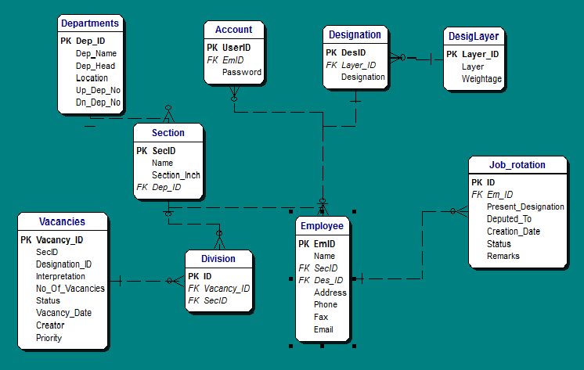**

**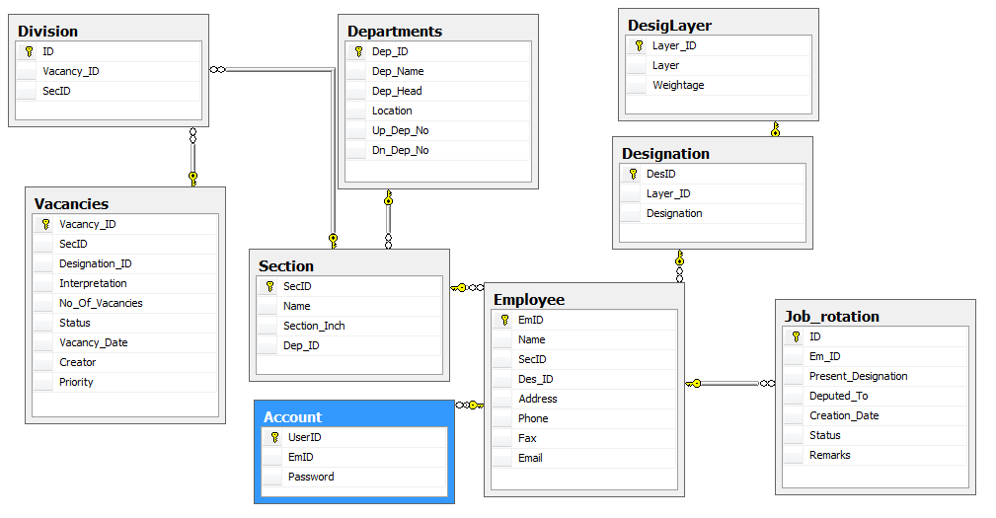**

**5.2 Desciption Table**

**Account Manager**

**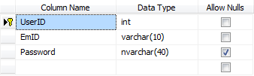**

|  |  |  |
| --- | --- | --- |
| **No** | **Fieldname** | **Description** |
| 1 | UserID | Number of Account (auto increment) |
| 2 | Password | Password of Account |
| 3 | EmID | Number of Employee |

**Departments**

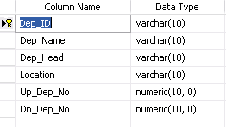

|  |  |  |
| --- | --- | --- |
| **No** | **Fieldname** | **Description** |
| 1 | Dep\_ID | Number of department |
| 2 | Dep\_Name | Name of department |
| 3 | Dep\_Head | Name of head department |
| 4 | Location | Location of department |
| 5 | Up\_Dep\_No | Number of Upper Department |
| 6 | Dn\_Dep\_No | Number of lower department |

**DesignLayer**

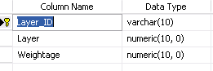

|  |  |  |
| --- | --- | --- |
| **No** | **Fieldname** | **Desription** |
| 1 | Layer\_ID | Number of Layer |
| 2 | Layer | Layer |
| 3 | Weightage | Weightage |

**Designation**

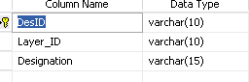

|  |  |  |
| --- | --- | --- |
| **No** | **Fieldname** | **Description** |
| 1 | DesID | Number of designation |
| 2 | Layer\_ID | Number of layer |
| 3 | Designation | Designation |

**Employee**

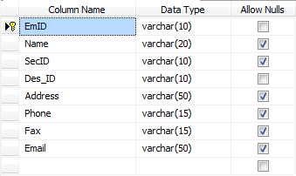

|  |  |  |
| --- | --- | --- |
| **No** | **Fieldname** | **Description** |
| 1 | EmID | Number of employee |
| 2 | Name | Name of employee |
| 3 | Dep\_ID | Number of department |
| 4 | Des\_ID | Number of designation |
| 5 | Address | Address of employee |
| 6 | Phone | Phone of employee |
| 7 | Fax | Fax of employee |
| 8 | Email | Email of employee |

**Job Rotation**

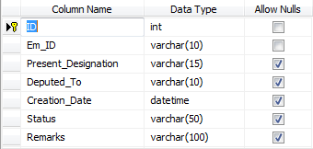

|  |  |  |
| --- | --- | --- |
| No | Fieldname | Description |
| 1 | ID | Number of job rotation |
| 2 | Em\_ID | Number of employee |
| 3 | Present\_Designation | Present designation |
| 4 | Deputed\_To | Deputed to |
| 5 | Creation\_Date | Date of creation |
| 6 | Status | Status of Job rotation |
| 7 | Remarks | Remarks of job rotation |

**Section**

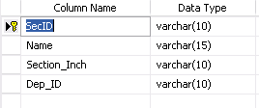

|  |  |  |
| --- | --- | --- |
| No | Fieldname | Description |
| 1 | SecID | Number of section |
| 2 | Name | Name of section |
| 3 | Section\_Inch | Section inch |
| 4 | Dep\_ID | Number of department |

**Vacancies**

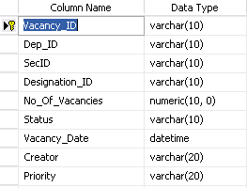

|  |  |  |
| --- | --- | --- |
| No | Fieldname | Description |
| 1 | Vacancy\_ID | Number of vacancy |
| 2 | Dep\_ID | Number of department |
| 3 | Sec\_ID | Number of section |
| 4 | Designation\_ID | Number of designation |
| 5 | No\_Of\_Vacancies | Numbert of vacancies |
| 6 | Status | Status |
| 7 | Vacancy\_Date | Date of vacancy |
| 8 | Creator | Vacancy creator |
| 9 | Priority | Priority |

**Division**

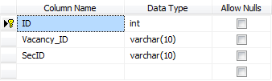

|  |  |  |
| --- | --- | --- |
| No | Fieldname | Description |
| 1 | ID | Number of vancancy fill details |
| 2 | Vacancy\_ID | Number of vacancy |
| 3 | Sec\_ID | Number of section |

**6.Site map**



**7.Interface System**

**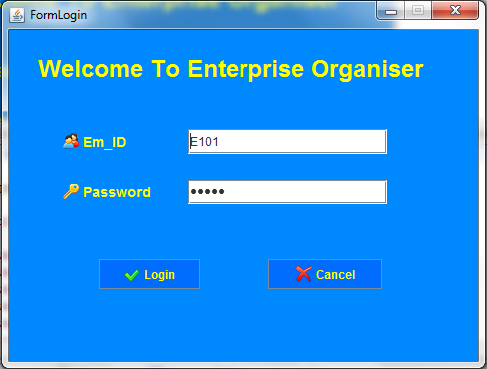**

**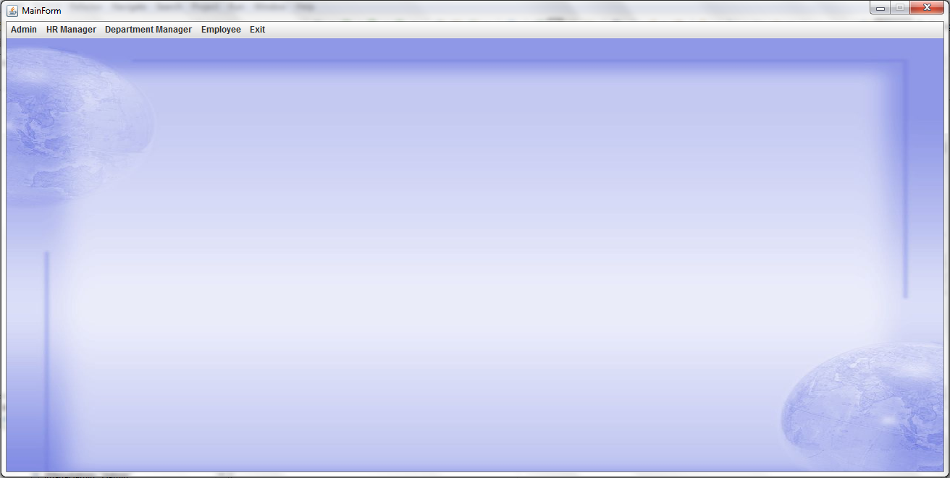**

**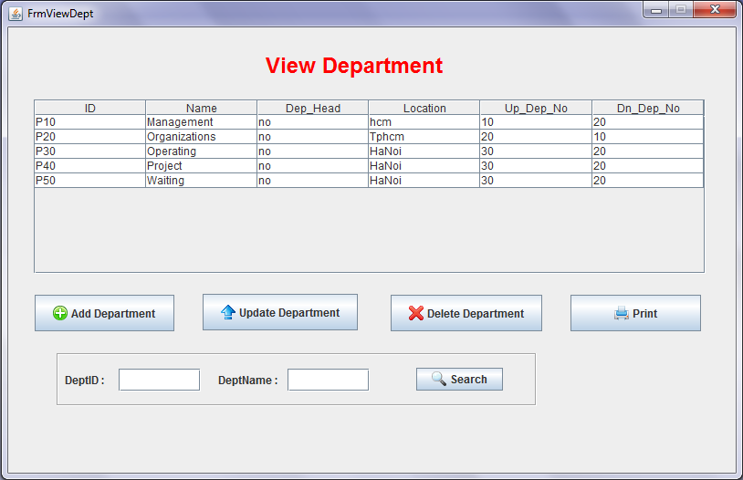**

**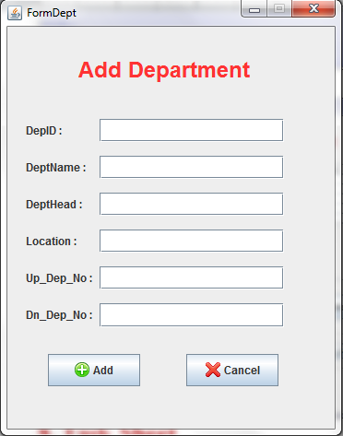**

**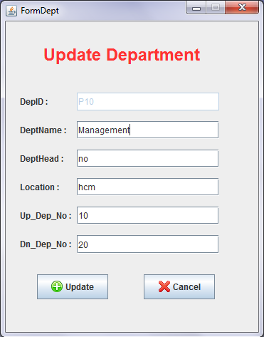**

**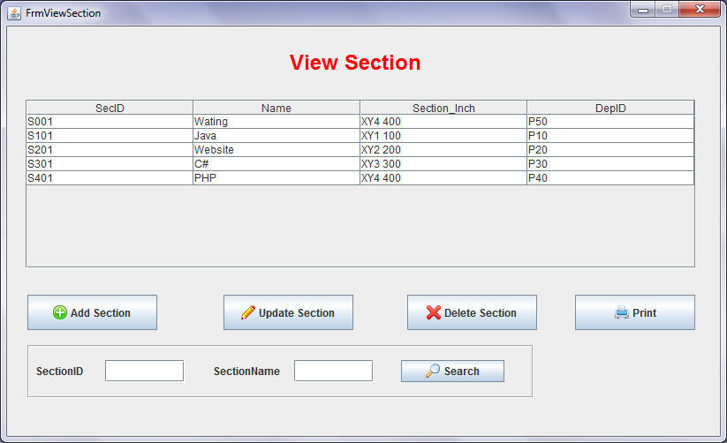**

**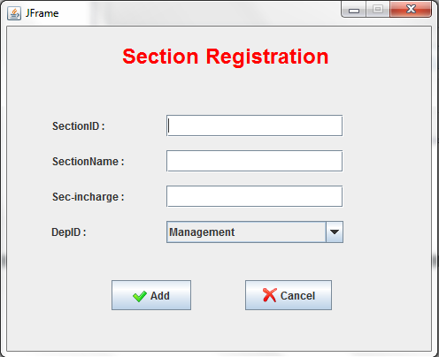**

**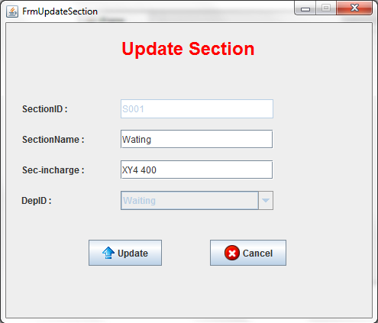**

**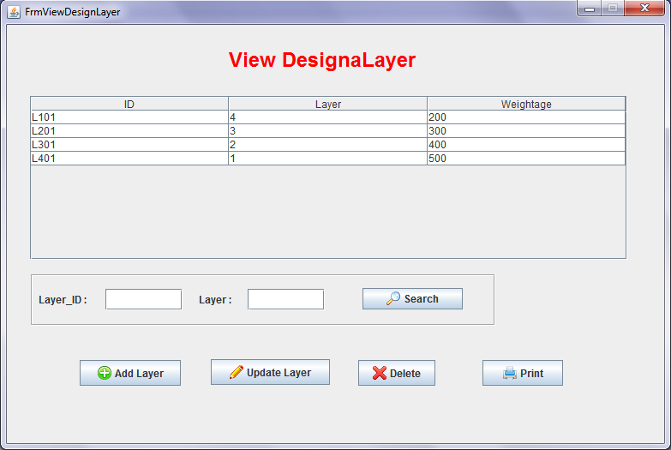**

**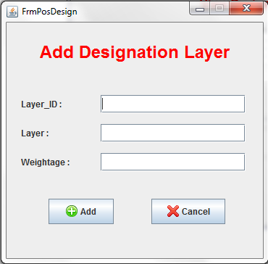**

**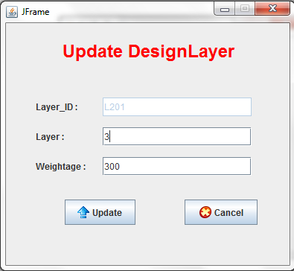**

**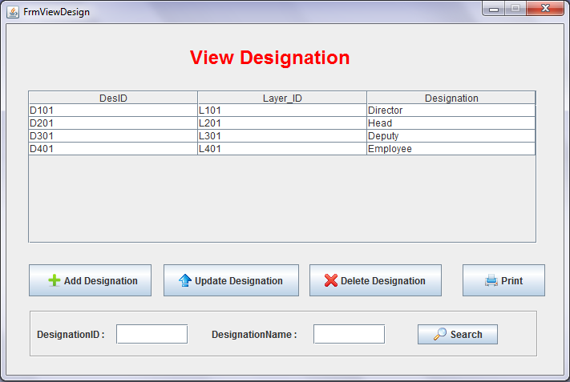**

**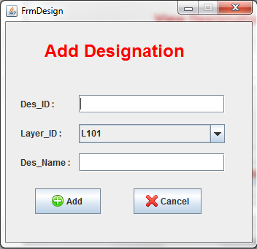**

**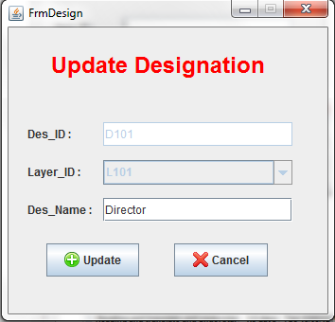**

**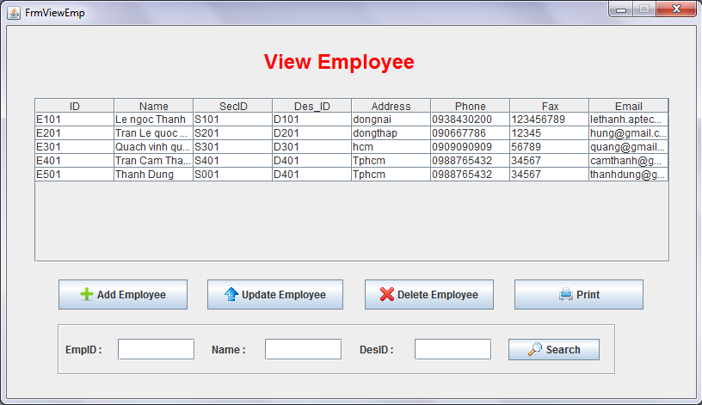**

**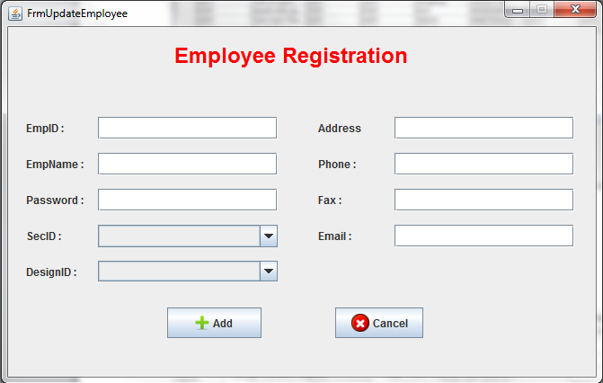**

**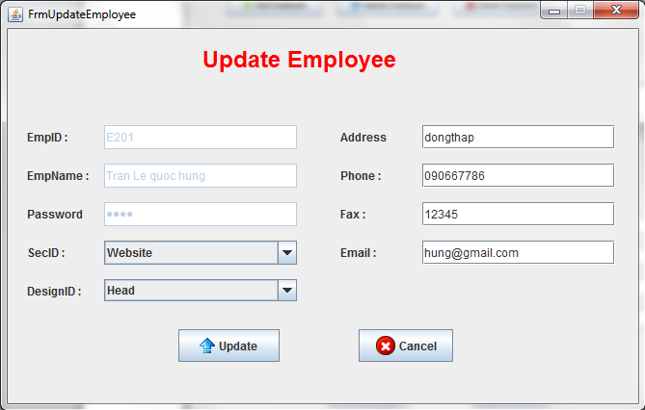**

**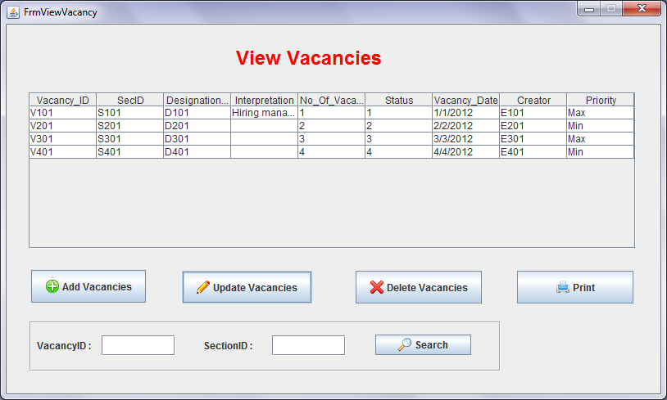**

**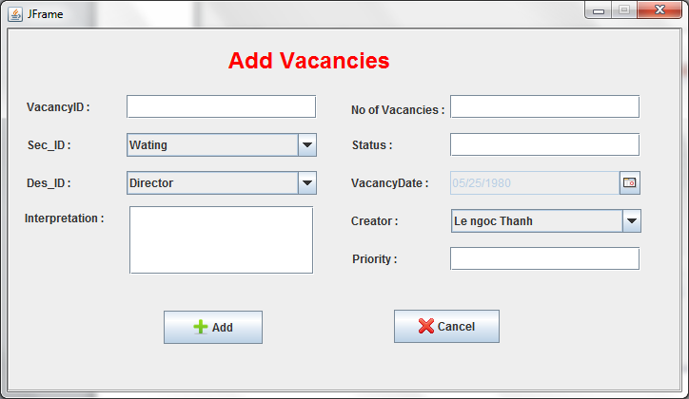**

**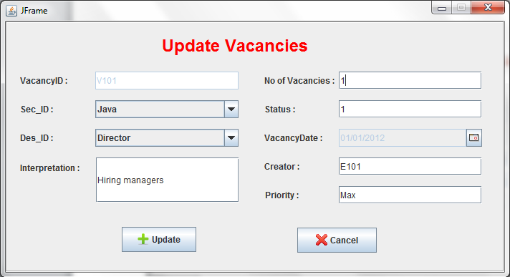**

**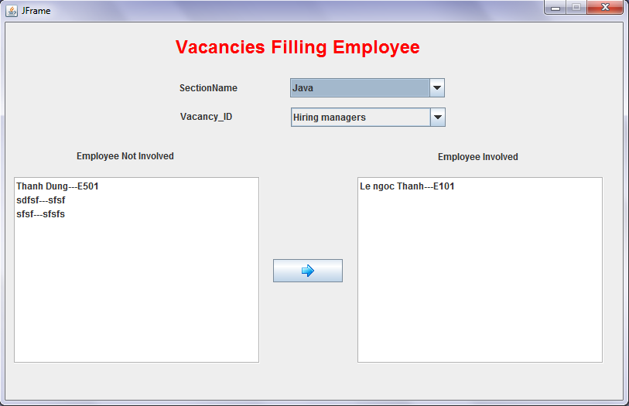**

**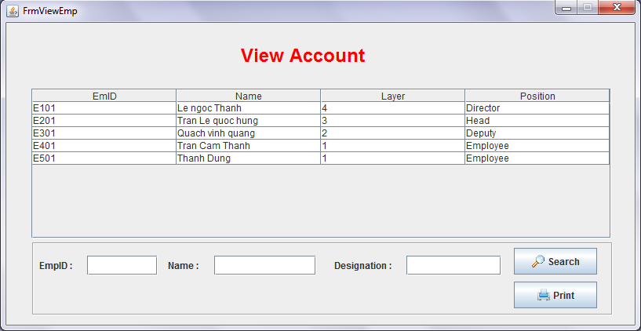**

**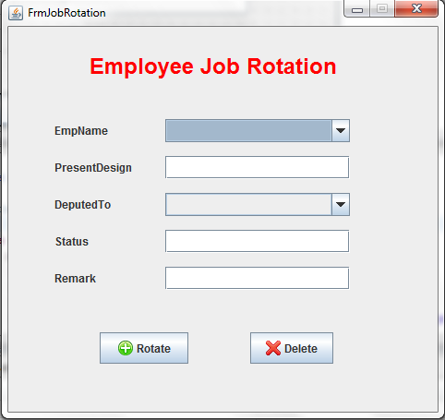**

**8. Task Sheet**

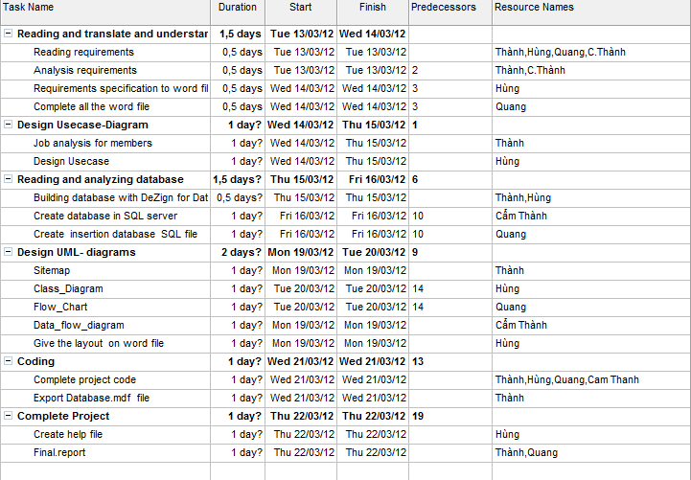

logo_aptech

**Project Title : Campaign Information System**

**A. System Requirement**

|  |  |  |
| --- | --- | --- |
| **Sr.** | **Item** | **Description** |
| 1 | OS | Window XP |
| 2 | Database | Microsoft SQL Server 2005 |
| 3 | Fonts | Unicode |
| 4 | Programing Language | Java |
| 5 | Editor | Eclipse |

**B. Installation Step**

**1. Install Microsoft SQL Server 2005**

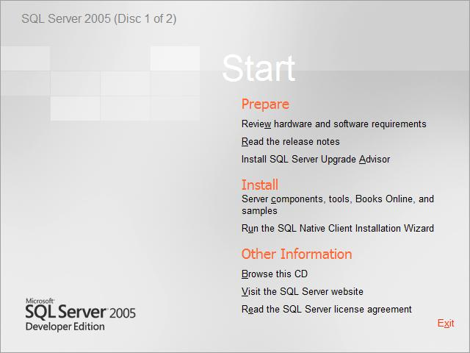

Click to install the “Server Component, tool, Books Online and samples”.

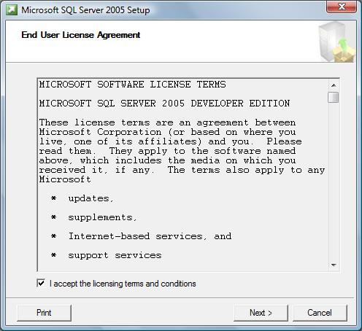

Accept the “End User License Agreement”. Click Next.

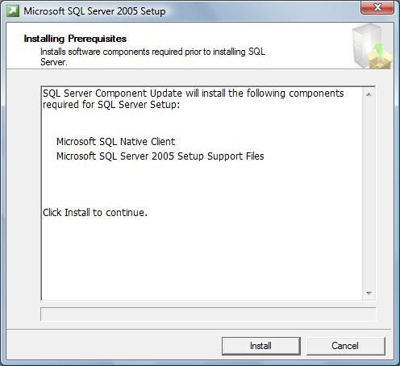

The Installing Perpetuates window will appear. Click Install

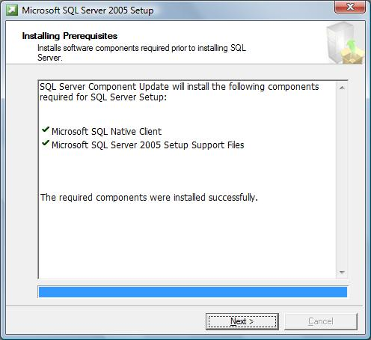

Then click Next to continue

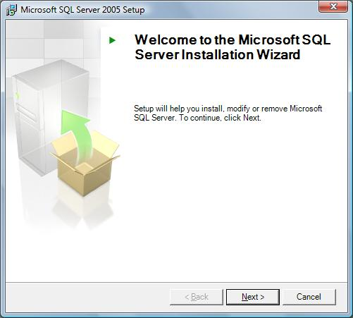

The SQL Server Installation Wizard will now appear. Click Next.

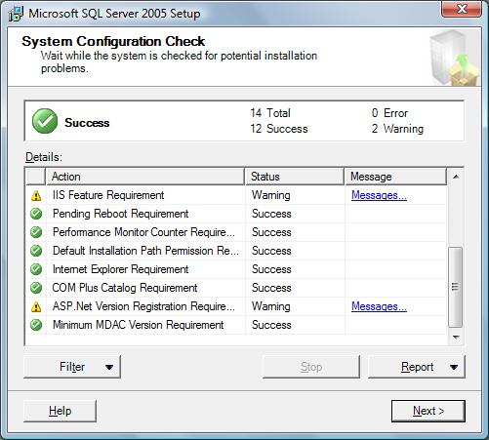

The System Configuration Check window will appear. The status of

each should indicate a status of “Success”. If everything checks out, click Next.

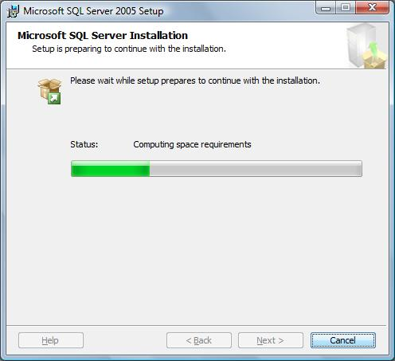

The SQL Server installation will begin to prepare the installation.

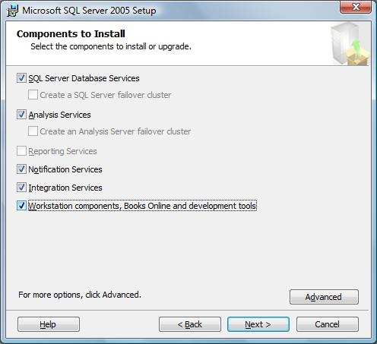

Check the followings boxes when the Components to install window appears.

Click Next when finished.

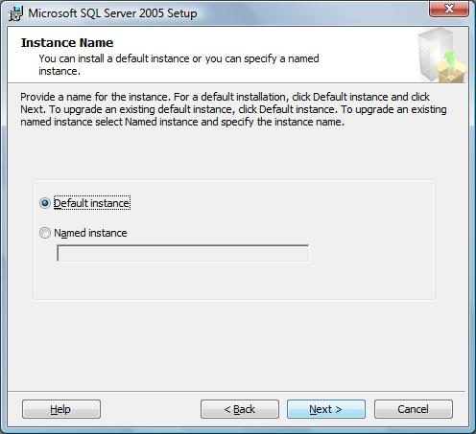

When the “Instance Name” window appears, be sure that

“Default Instance” is selected and click Next.

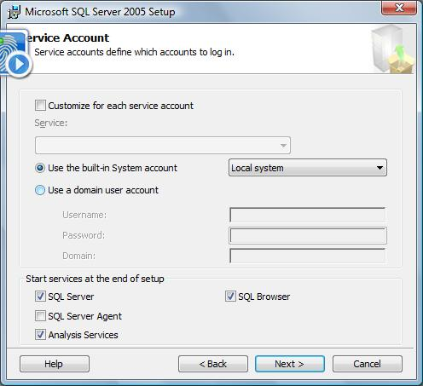

On the “Service Account” window, please select the option for “Use the built-in System account”. Be sure that “Local System” is selected. Click Next when finished.

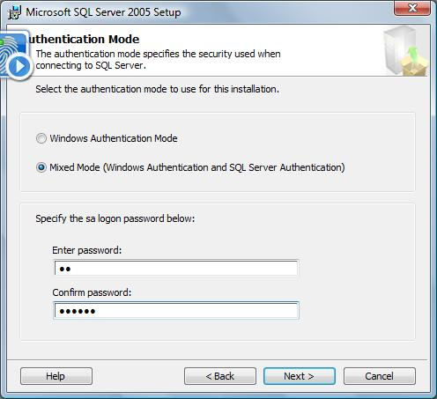

Select the “Mixed Mode” option on the “Authentication Mode” window.

At this point you may specify an **sa** logon and password: **123456**.

Leave it blank. Click Next when finished.

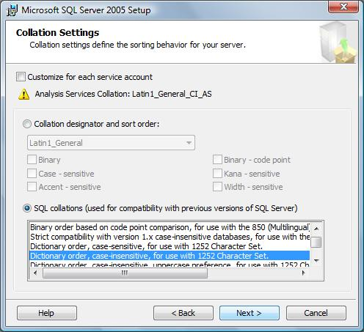

For the “Collation Settings” window, please select the option for “Dictionary order, case-insensitive, accent-insensitive, for use with 1225 Character Set”

. Click Next when finished.

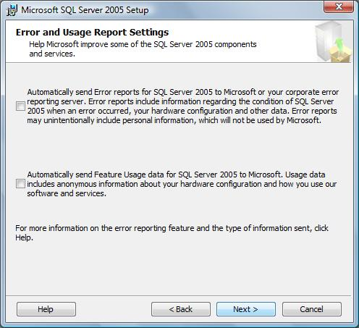

The Error and Usage Report Settings windows will appear, if you wish to send info to Microsoft, select each item, otherwise, please click Next to continue

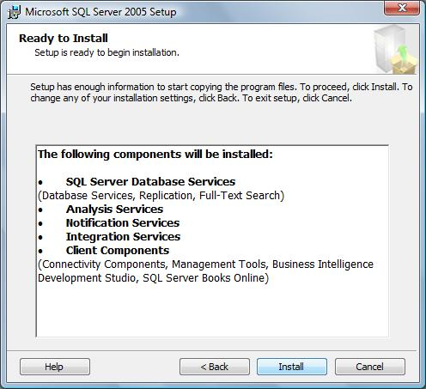

The Ready to Install window will appear. Review the components getting installed and click the Next button to continue.

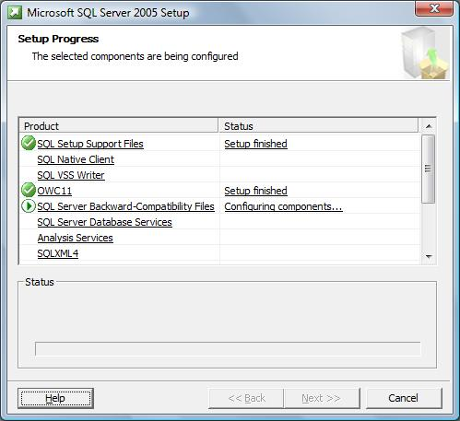

The “Setup Progress” window will appear. This will take several minutes to finish.

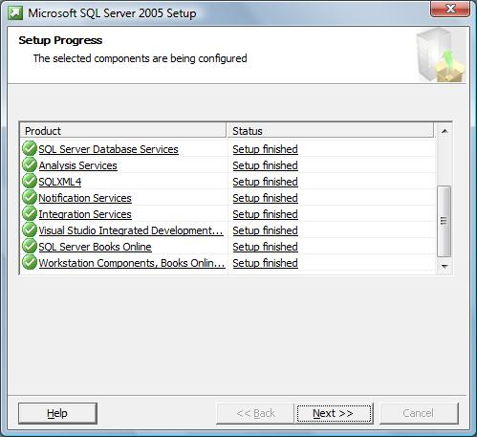

When the setup finishes, each status should indicate that the “Setup Finished”. Click Next to continue.

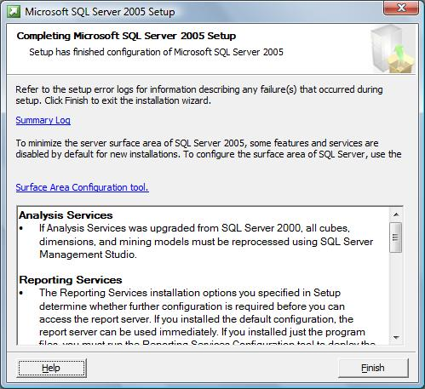

When completed, the “Completing Microsoft SQL Server 2005 Setup” window will appear. Review the services installed and click Finish.

**2. Configuring MS SQL Server 2005:**

To enable using application, you must config MS SQL Server 2005.At first, you configure “port”

-Select Start menu - Microsoft SQL Server 2005\Configuration Tools\SQL Server Configuration Manager

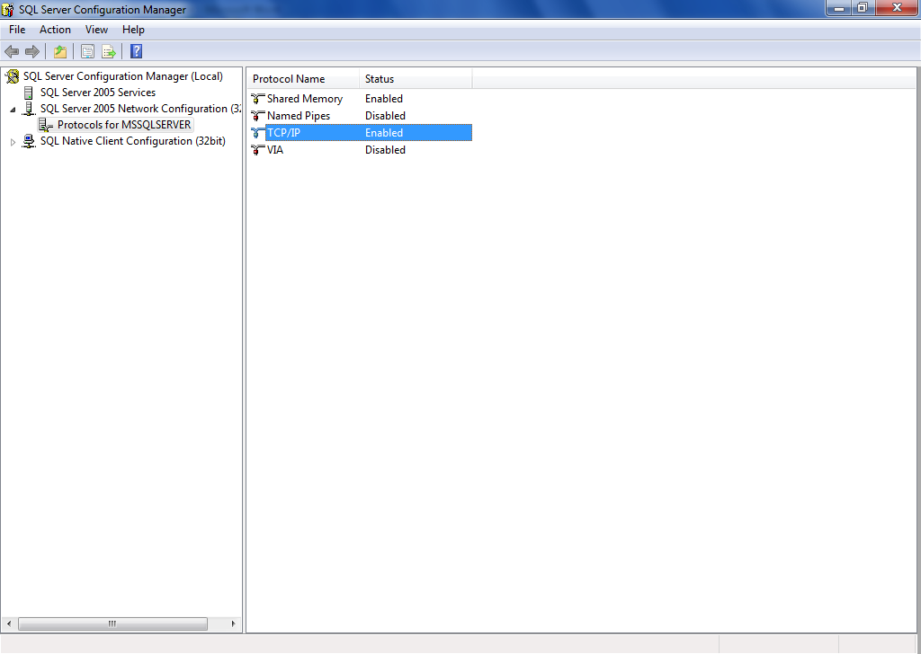

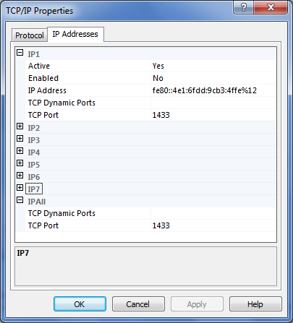

Set TCP Port : 1433

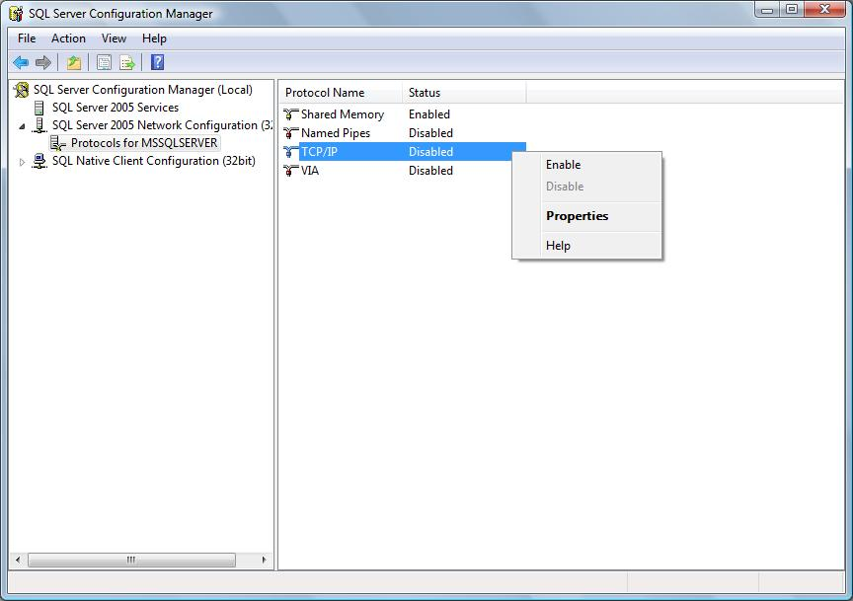

Right click on TCP/IP choose Enable

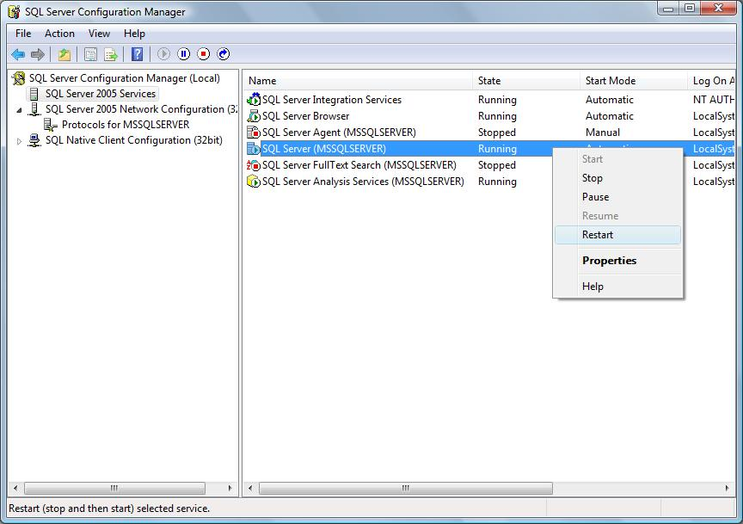

Choose SQL Server 2005 Services in left windows and right click on SQL Server (MSSQLSERVER) choose Restart

**3. Install Java Development Kit (JDK 1.6)**

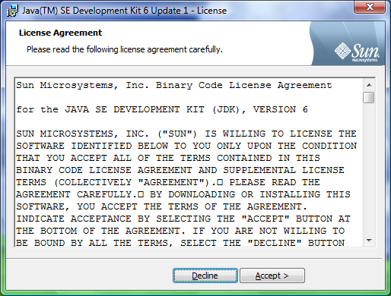

Choose Accept to setup

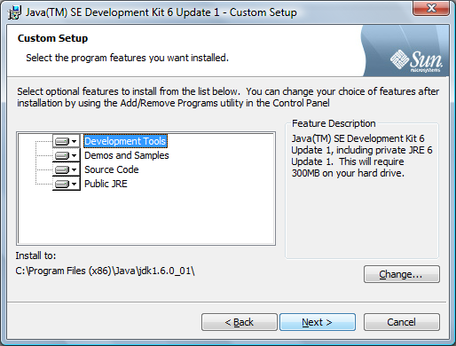

Click Next to continue

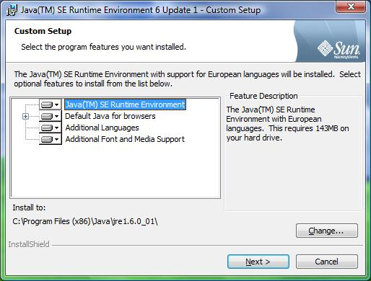

Click Next to continue

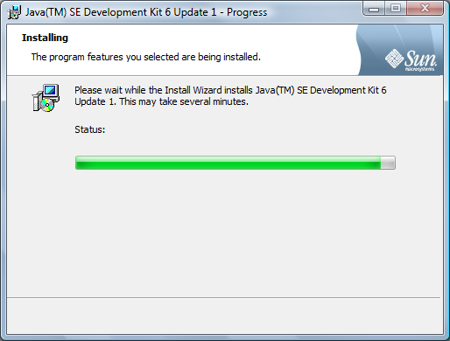

The Jdk installation will begin to prepare the installation.

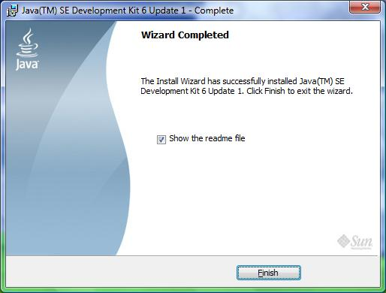

Click Finish to complete

**4. Setup Database**

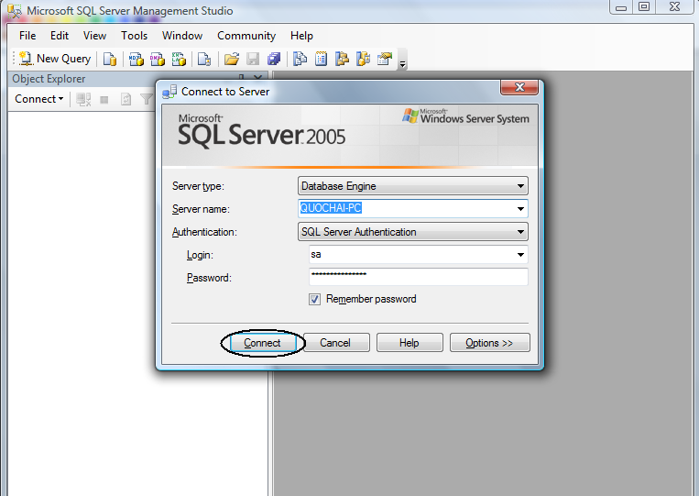

Field Authentication: choose SQL Server Authentication

Field Login: input “sa”

Field Password: input “123456”

Then click Connect

**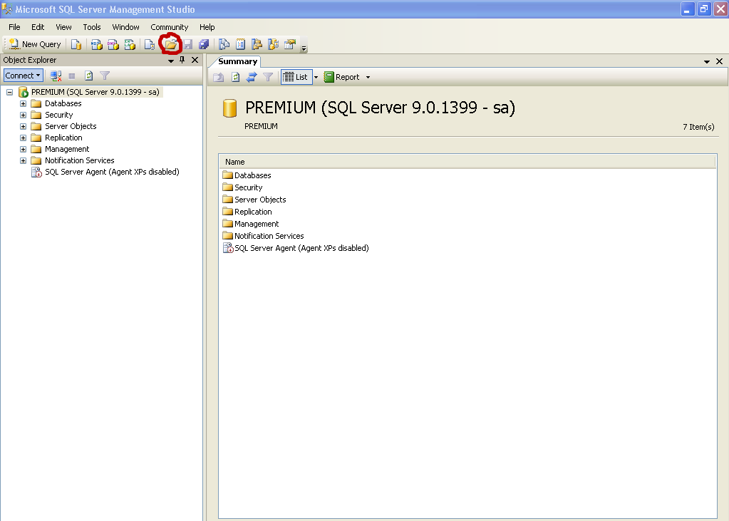**

Press icon Open File or use Ctrl + O🡺 Open🡺 file to open the file query

**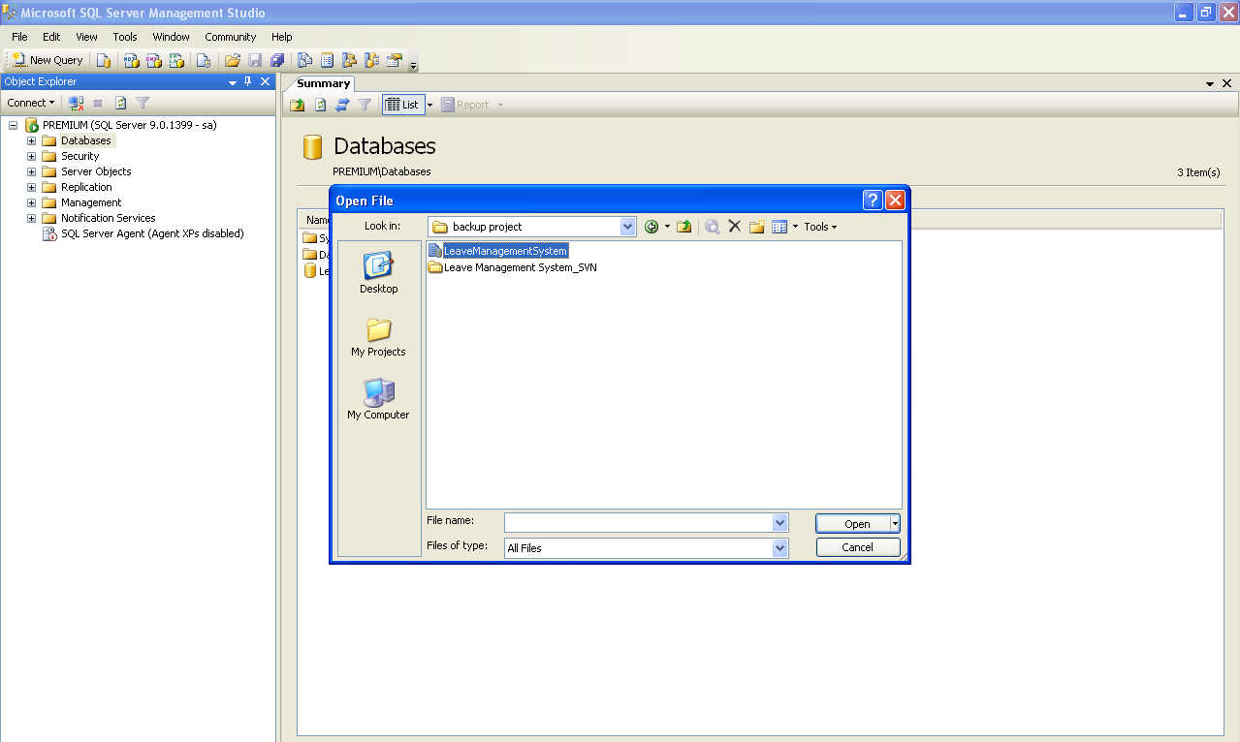**

Browse to file SQL query in the project folder/Database/Leavemanagermentsystem file then click Open

**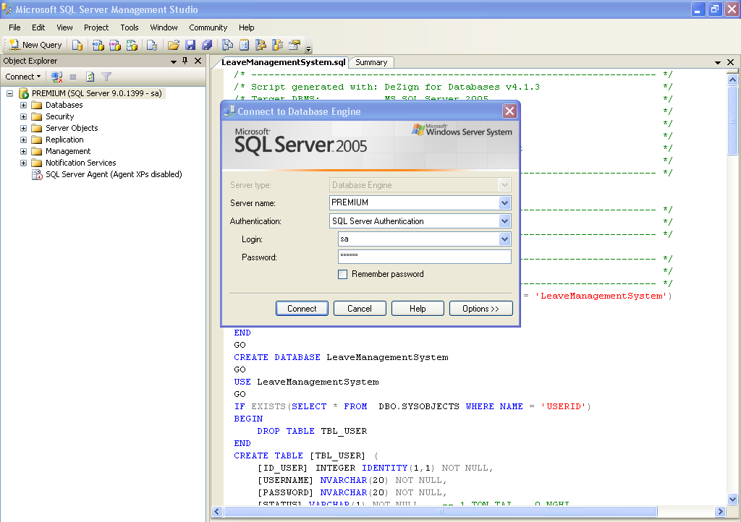**

Click Connect to continue

logo_aptech

**\* Login:**

****

Enter Em\_ID and Password then click Login button.

If u sign in successfull. Main Form will be displayed as below:

- Admin:

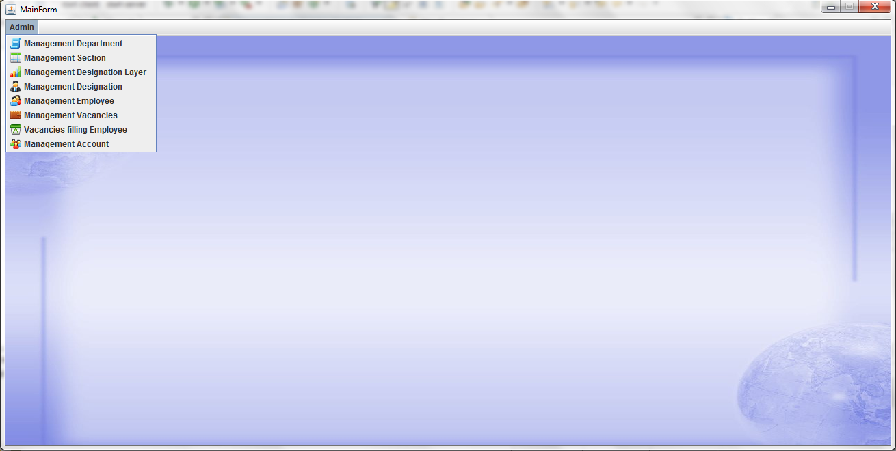

- HR Manager:

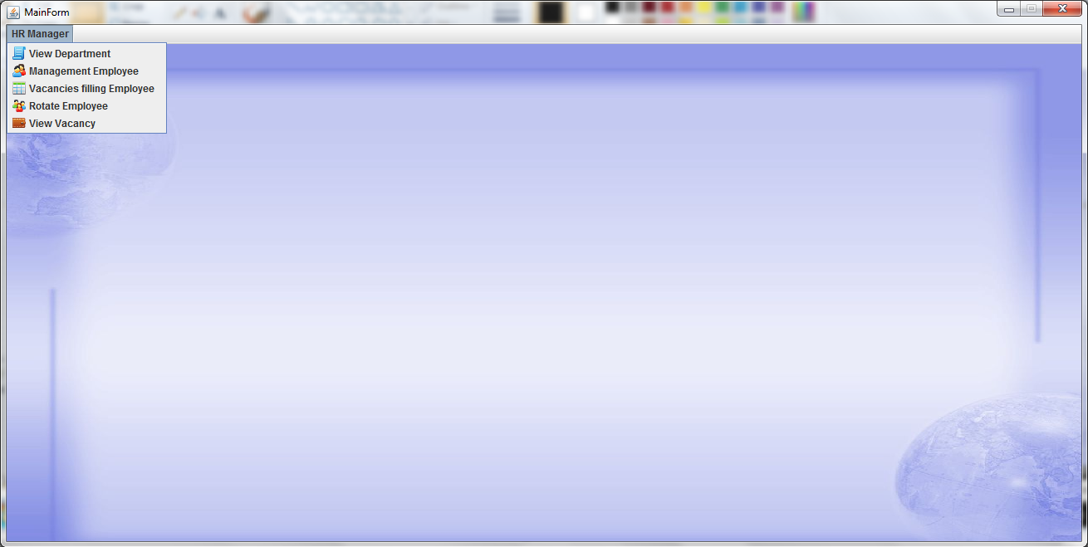

- Department Manager:

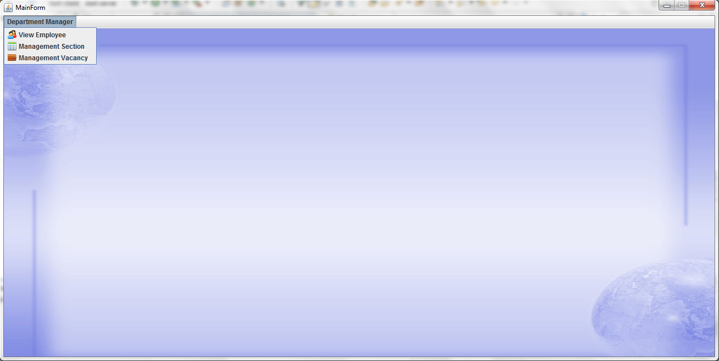

- Employee:

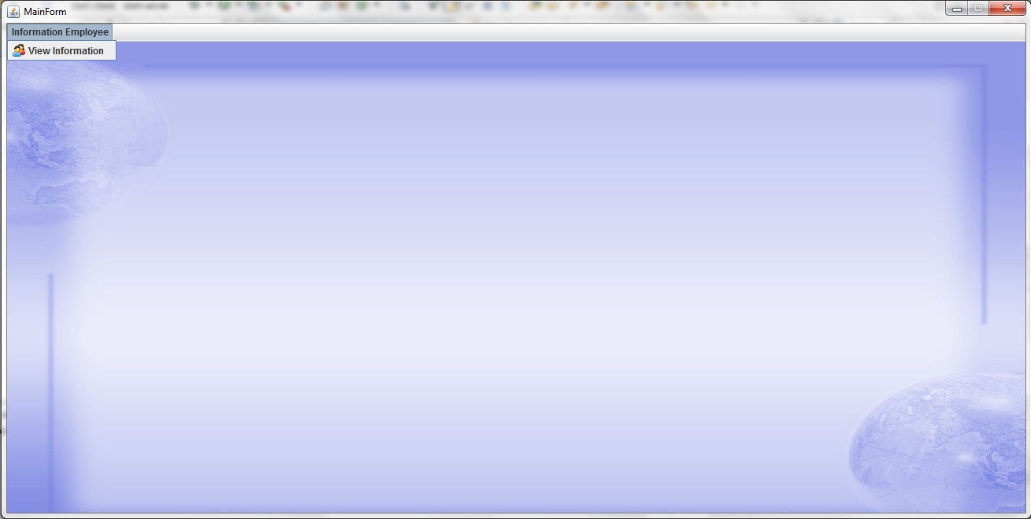

**\* Manage Department:**

Click on tab “Manage Department”. View Department Form will be displayed as below:

****

***-*** *Add Department:*

Click Add Department button on View Department Form. Add Department Form will be displayed as below:

****

Enter information into this form and click Add button. If you want to close this form, click Cancel button.

*- Update Department:*

Click Update Department button on View Department Form. Update Department Form will be displayed as below:

****

Edit information on this form and click Update button. If you want to close this form, click Cancel button.

*- Search Department:*

Enter DeptID or DeptName you want to search and click Search button on View Department Form. View Department Form will show the information of department you want to search.

*- Delete Department:*

Choose department you want to delete and click Delete button. It will be deleted on database and won’t be showed on View Department Form.

**\* Manage Section:**

Click on tab “Manage Section”. View Section Form will be displayed as below:

****

***-*** *Add Section:*

Click Add Section button on View Section Form. Add Section Form will be displayed as below:

****

Enter information into this form and click Add button. If you want to close this form, click Cancel button.

*- Update Section:*

Click Update Section button on View Section Form. Update Section Form will be displayed as below:

****

Edit information on this form and click Update button. If you want to close this form, click Cancel button.

*- Search Section:*

Enter SectionID or SectionName you want to search and click Search button on View Section Form. View Section Form will show the information of section you want to search.

*- Delete Section:*

Choose section you want to delete and click Delete button. It will be deleted on database and won’t be showed on View Section Form.

**\* Manage Designation Layer:**

Click on tab “Manage Designation Layer”. View Designation Layer Form will be displayed as below:

****

***-*** *Add Designation Layer:*

Click Add Layer button on View Designation Layer Form. Add Designation Layer Form will be displayed as below:

****

Enter information into this form and click Add button. If you want to close this form, click Cancel button.

*- Update Designation Layer:*

Click Update Layer button on View Designation Layer Form. Update Designation Layer Form will be displayed as below:

****

Edit information on this form and click Update button. If you want to close this form, click Cancel button.

*- Search Designation Layer:*

Enter Layer\_ID or Layer you want to search and click Search button on View Designation Layer Form. View Designation Layer Form will show the information of Layer you want to search.

*- Delete Designation Layer:*

Choose layer you want to delete and click Delete button. It will be deleted on database and won’t be showed on View Designation Layer Form.

**\*Manage Designation:**

Click on tab “Manage Designation”. View Designation Form will be displayed as below:

****

***-*** *Add Designation:*

Click Add Designation button on View Designation Form. Add Designation Form will be displayed as below:

****

Enter information into this form and click Add button. If you want to close this form, click Cancel button.

*- Update Designation:*

Click Update Designation button on View Designation Form. Update Designation Form will be displayed as below:

****

Edit information on this form and click Update button. If you want to close this form, click Cancel button.

*- Search Designation:*

Enter DesignationID or DesignationName you want to search and click Search button on View Designation Form. View Designation Form will show the information of designation you want to search.

*- Delete Designation:*

Choose designation you want to delete and click Delete button. It will be deleted on database and won’t be showed on View Designation Form.

**\* Manage Employee:**

Click on tab “Manage Employee”. View Employee Form will be displayed as below:

****

***-*** *Add Employee:*

Click Add Employee button on View Employee Form. Add Employee Form will be displayed as below:

****

Enter information into this form and click Add button. If you want to close this form, click Cancel button.

*- Update Employee:*

Click Update Employee button on View Employee Form. Update Employee Form will be displayed as below:

****

Edit information on this form and click Update button. If you want to close this form, click Cancel button.

*- Search Employee:*

Enter EmID or Name or DesID you want to search and click Search button on View Employee Form. View Employee Form will show the information of employee you want to search.

*- Delete Employee:*

Choose employee you want to delete and click Delete button. It will be deleted on database and won’t be showed on View Employee Form.

**\* Manage Vacancy:**

Click on tab “Manage Vacancies”. View Vacancies Form will be displayed as below:

****

***-*** *Add Vacancies:*

Click Add Vacancies button on View Vacancies Form. Add Vacancies Form will be displayed as below:

****

Enter information into this form and click Add button. If you want to close this form, click Cancel button.

*- Update Vacancies:*

Click Update Vacancies button on View Vacancies Form. Update Vacancies Form will be displayed as below:

****

Edit information on this form and click Update button. If you want to close this form, click Cancel button.

*- Search Vacancies:*

Enter VacanciesID or SectionID you want to search and click Search button on View Vacancies Form. View Vacancies Form will show the information of vacancies you want to search.

*- Delete Vacancies:*

Choose vacancies you want to delete and click Delete button. It will be deleted on database and won’t be showed on View Vacancies Form.

**\* Vacancies Filling Employee:**

Click on tab “Vacancies Filling Employee”. Assignment Employee Form will be displayed as below:

****

Choose SectionName and Vacancy\_ID you want to filling. Left list will be showed employee hasn’t been assign, right list will be showed employee has been assign. Choose employee you want to assign for section you choose on left list and click => button. This employee will be moved to right list and assigned for this section.

**\* View Account:**

Click on tab “View Account”. View Account Form will be displayed as below:

****

*- Search Account:*

Enter EmpID or Name or DesignationID you want to search and click Search button on View Account Form. View Account Form will show the information of vacancies you want to search.

**\* Job Rotation Employee:**

Click on tab Job Rotation Employee. Job Rotation Employee Form will be displayed.

****

Edit information of this form and click Rotate button.